**ATTRITION AND PERFORMANCE DASHBOARD**

1. **MIND MAP:**

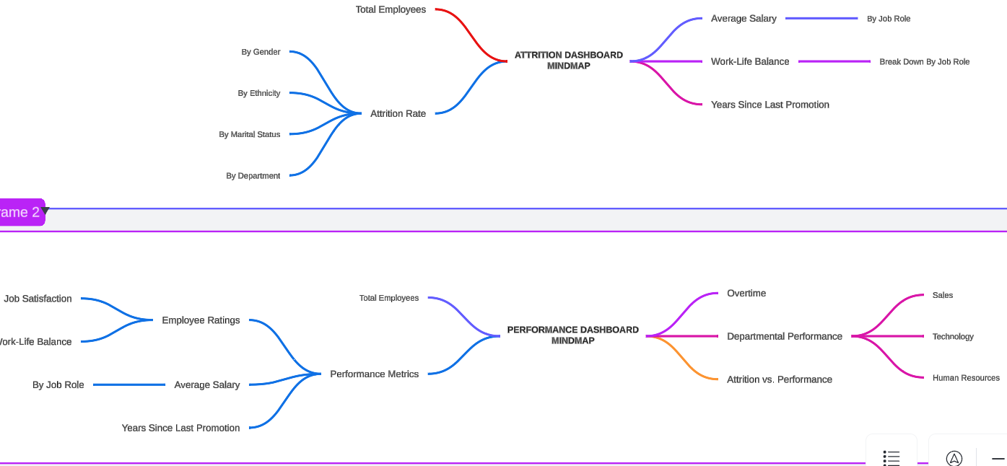

**Attrition Dashboard Mind map**

This dashboard explores employee attrition and related metrics, providing insights into:

1. Total Employees:
   * Breakdown by Gender, Ethnicity, Marital Status, and Department to identify trends and demographics.
2. Attrition Rate:
   * Highlights overall attrition rates and identifies patterns within groups.
3. Additional Metrics:
   * Average Salary: Analysis of salary distribution by job roles.
   * Work-Life Balance: Explored with breakdowns by job role to assess balance within different teams.
   * Years Since Last Promotion: Examines how promotion timelines impact employee retention.

**Performance Dashboard Mind map**

This dashboard focuses on performance metrics, including employee satisfaction and departmental achievements:

1. Total Employees:
   * Tracks workforce size and its impact on performance indicators.
2. Performance Metrics:
   * Employee Ratings: Metrics like Job Satisfaction and Work-Life Balance, categorized by job role.
   * Average Salary: Linked to performance ratings and years since the last promotion.
3. Departmental Performance:
   * Overtime: Assesses overtime trends and their impact on departmental output.
   * Attrition vs. Performance: Correlates attrition data with performance in key departments like Sales, Technology, and HR.

**2.ATTRITION DASHBOARD:**

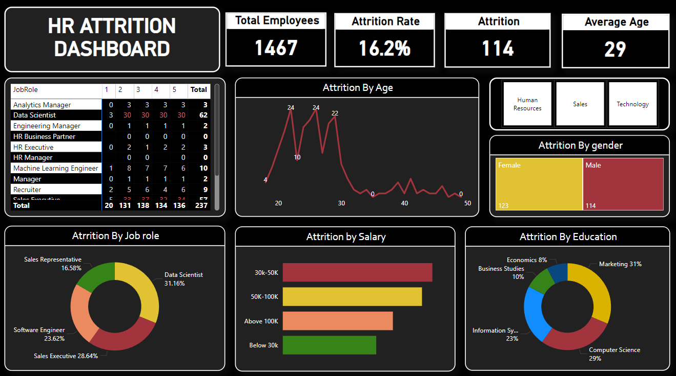

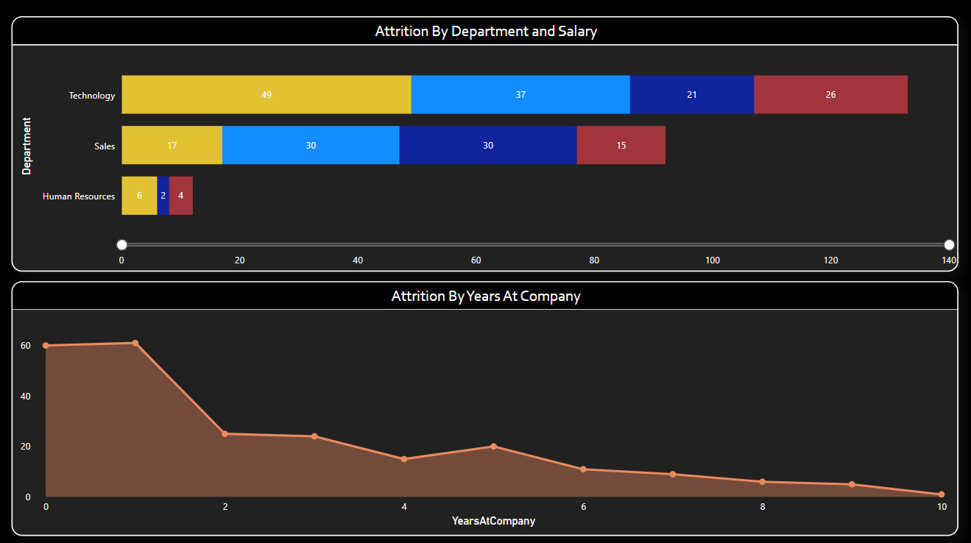

This HR Attrition Dashboard visualizes key insights regarding employee attrition in an organization. Here's a detailed breakdown of its components:

**Top Summary KPIs:**

1. **Total Employees**: Displays the total workforce (1467 employees).
2. **Attrition Rate**: Shows the percentage of employees leaving the organization (16.2%).
3. **Attrition Count**: Provides the exact number of employees who left (114).
4. **Average Age**: Indicates the average age of employees in the dataset (29 years).

**Middle Section:**

**Job Role-wise Attrition:**

* A matrix visualization highlights the attrition count across different roles, with notable attrition for **Data Scientists** (62) and **Sales Executives** (high numbers across all bands).

**Attrition by Age:**

* A line chart visualizes attrition peaks around the age of 24, with a sharp decline in attrition beyond age 30.

**Department Filters:**

* Interactive filters allow users to segment data by departments such as Human Resources, Sales, and Technology.

**Attrition by Gender:**

* A bar chart comparison shows more females (123) leaving compared to males (114).

**Bottom Section:**

**Attrition by Job Role (Pie Chart):**

* The roles with the highest attrition rates:
  + Data Scientists (31.16%)
  + Sales Executives (28.64%)
  + Software Engineers (23.62%)

**Attrition by Salary:**

* A bar chart reveals attrition is highest in the **30K-50K** salary range, followed by **50K-100K**.

**Attrition by Education:**

* A donut chart highlights education-related trends:
  + Most attrition comes from **Marketing (31%)** and **Computer Science (29%)** fields.

**Bottom Section (Detailed Visuals):**

**Attrition by Department and Salary:**

* A stacked bar chart segments attrition by salary bands within departments:
  + **Technology** has the highest attrition across all salary levels.
  + **Sales** and **Human Resources** show lower attrition numbers.

**Attrition by Years at Company:**

* A line chart depicts a steep decline in attrition as tenure increases, with the highest attrition occurring within the first year of employment.

**Key Insights:**

1. Attrition is high among younger employees, especially those aged 24.
2. **Data Scientists** and **Sales Executives** face the most attrition.
3. Employees in the **30K-50K salary range** and **Marketing graduates** have higher attrition rates.
4. Technology department experiences significant attrition, regardless of salary levels.
5. Retention improves significantly with employee tenure, especially after the first year.

This dashboard helps HR teams identify focus areas for retention strategies, such as role-specific interventions, salary adjustments, or improving the experience for new hires.

**3.PERFORMANCE DASHBOARD:**

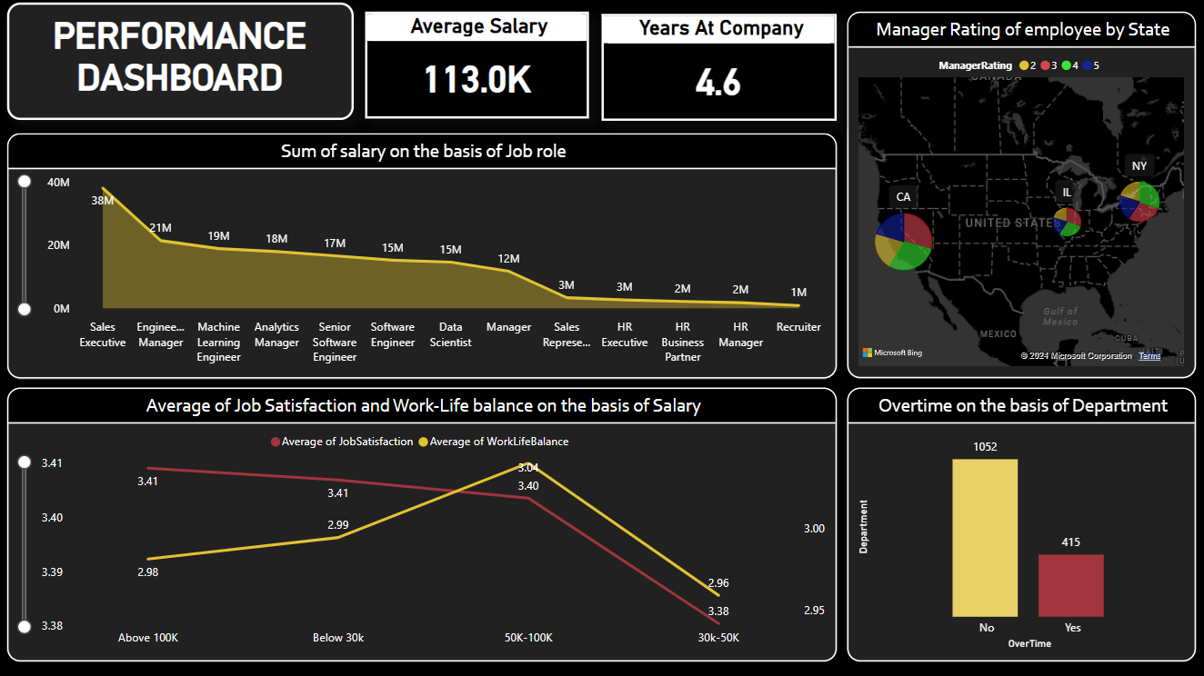

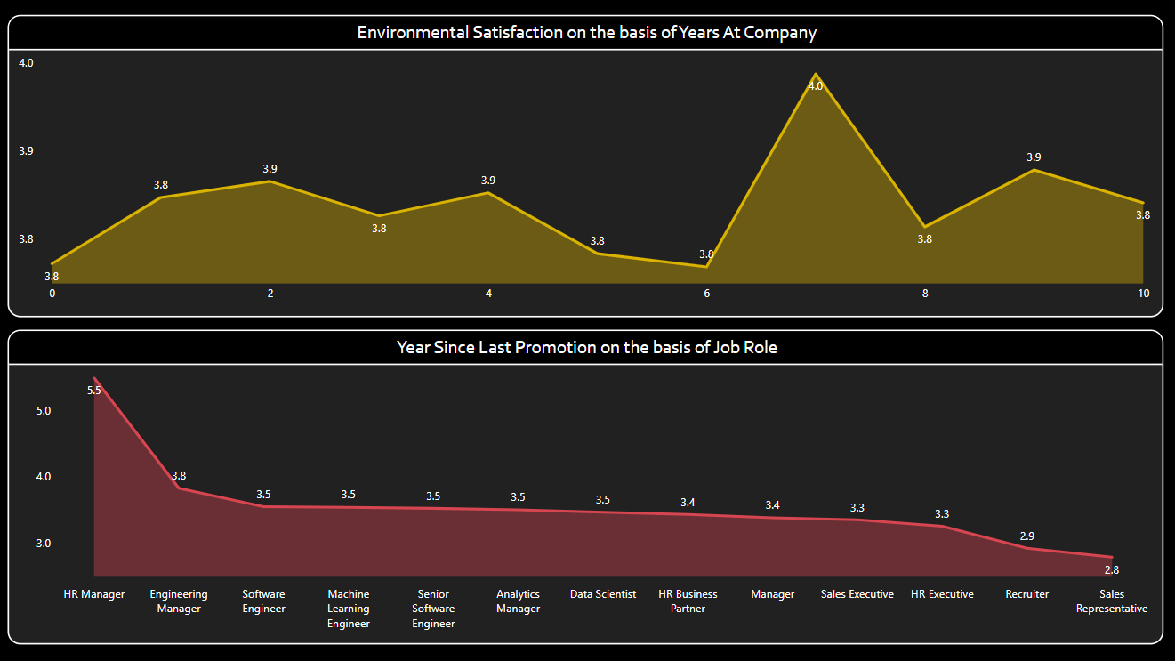

This performance dashboard provides insights into various key performance indicators (KPIs) for employees in an organization. Here's a detailed explanation of each section:

**1. Overview Section**

* **Average Salary:** Displays the average salary of employees, which is $113K.
* **Years at Company:** Indicates the average tenure of employees, which is 4.6 years.

**2. Salary Analysis**

* **Sum of Salary by Job Role:**
  + The graph highlights how salaries are distributed across different job roles.
  + Highest salaries are associated with **Sales Executives** and **Engineering Managers**, while roles like **HR Manager**, **HR Executive**, and **Recruiter** have lower salary allocations.

**3. Manager Rating by State**

* A map representation shows manager ratings of employees across different states.
  + **CA, IL, and NY** are key regions with ratings spread across categories (2 to 5). Each pie chart indicates the proportion of ratings in those states.

**4. Work-Life Balance and Job Satisfaction**

* **Job Satisfaction vs. Work-Life Balance (by Salary):**
  + Employees earning **below $30K** show the lowest averages for both job satisfaction and work-life balance.
  + Those earning **$50K to $100K** have relatively higher job satisfaction and work-life balance.
  + Satisfaction tends to dip slightly for employees with salaries **above $100K**.

**5. Overtime Analysis by Department**

* The bar chart compares the number of employees working overtime:
  + A significant majority (1052) do not work overtime.
  + A smaller proportion (415) engage in overtime work.

**6. Environmental Satisfaction**

* **By Years at Company:**
  + Satisfaction is relatively steady around **3.8 to 4.0** across different tenures.
  + A noticeable peak occurs at **6 years** with an average satisfaction score of **4.0**.

**7. Years Since Last Promotion**

* **By Job Role:**
  + **HR Managers** have the highest average years since their last promotion (5.5 years).
  + Roles like **Recruiters** and **Sales Representatives** show the shortest time since promotion (~2.8 years).

**Key Insights**

1. **Salary Disparity:** High salary gaps exist between roles, potentially influencing satisfaction and turnover rates.
2. **Promotion Challenges:** Certain roles face longer gaps between promotions, especially managerial positions.
3. **Work-Life Balance Impact:** Low earners report poorer work-life balance, emphasizing the need for equitable support across salary levels.
4. **Regional Insights:** State-wise manager ratings can inform location-based HR strategies.

This dashboard can assist HR teams and management in identifying areas for improvement and optimizing employee performance and satisfaction strategies.

**THANK YOU!**